VAH Harness User Guide

Synopsis: This document describes how to use VAH Harness.
Approved By: Johnny Cao
Reviewers: Johnny Cao
Chen Li
Owner: Chen Li
Author: Chen Li
Document
Version: 1.0
Date: 26 Sep 2011
Status: Draft
Doc Id/ Loc: N/A

This document contains information proprietary to Thomson Reuters, and may not be reproduced, disclosed or used in whole or part without the express written permission of Thomson Reuters.
© 2011 Thomson Reuters
Document History
Date | Version | Status | Author | Description of Change
16-Nov-2011 | 0.1 | Draft | Chen Li | Initial draft
28-Nov-2011 | 0.2 | Draft | Chen Li | Adding Adapter setting for VAH, VAH Harness and TG
27-Dec-2011 | 0.3 | Draft | Chen Li | Adding configurable item for VAH Harness
26-Sep-2012 | 1.0 | Draft | Chen Li | New features on VAH Harness Version1.0

References/Bibliography
# | Title / Document ID | Location | Author | Date
1 | TRWF Prototype | http://www.oak.ime.reuters.com/~apidev/trwf/ | N/A | N/A
2 | Traffic Generator | http://idndev.uki.ime.reuters.com/group/DDSTools/TraffGenOverview.htm | Sophia Li | 10-Dec-2010
Glossary
For more information, see the Thomson Reuters Global Acronym and Abbreviation Database (http://www.ime.reuters.com/acronym/index.asp):
Abbreviation/Terms | Definition
MTP | Multicast Transport Protocol
RSSL | Thomson Reuters Source Sink Library
TRWF | Thomson Reuters Wire Format
Content
1 Introduction to VAH Harness 4
2 VAH Harness Structure 4
2.1 The location of installation package 4
2.2 Structure of installation package 5
2.3 QF/Boost/TRWF Version 5
3 Installing VAH Harness 6
3.1 Pre dependency 6
3.2 Setting ENV Parameter for VAH Harness 6
3.3 Setting ENV Parameter for VAH 9
3.4 Setting ENV Parameter for TG 9
3.5 Launch VAH Harness 10
3.5.1 Launch VAH Harness 10
3.5.2 Launch VAH Harness UI 11
3.5.3 Launch VAH 12
3.5.4 Launch ‘Traffic Generator’ 12
4 Using VAH Harness 13
4.1 Fabricate a Source Response Message 13
4.1.1 Fabricate a response message by TG 13
4.1.2 Fabricate a response message by VAH Harness 13
4.2 Send Following Update Message 14
Appendix 1 16

Introduction to VAH Harness
VAH Harness is a tool used to
- Perform Login Process for VAH via (RSSL+TRWF2) protocol
- Provide Source Directory Information for VAH via (RSSL+TRWF2) protocol
- Handle Source Subscription from VAH via (RSSL+TRWF2) protocol
- Relay TRWF2 format messages in MTP to VAH
- Configurable Item solicited response message (L1/L2)
- Support multiple constitute (64 constitutes) and CBR response
This user guide introduces how to install and use VAH Harness.
To use VAH Harness, you must have understanding of the following knowledge:
- TRWF. Refer to Ref.1.
- MTP and UDP. Refer to Ref.2.
- XML. Refer to http://www.w3.org/XML/.
- Traffic Generate

VAH Harness Structure

The location of installation package
Please find the latest version at link below:
http://portal.emea.ime.reuters.com/sites/IDN_Core_Development/Real_Time_Value_Add_NG/EVAI%20V100/Tools/VahHarness
Currently, 32 and 64 Bits Release Version are provided, please choose the appropriate version according to actual request.
Download the installation package on to local PC, and extract the installation package (zip file). There are 8 folders and 1 plain text file in this zip file. (Please find the screenshot below).
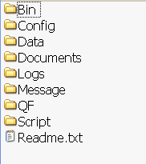

Structure of installation package
Directory/File | Description
Bin | Directory for Dll
Config | Configuration file directory
Data | Dictionary and private configuration
Document | Document
Logs | Log directory for VAH Harness
Message | Message(s) for Traffic Generator with ‘.xml’ format
QF | Quantum Framework Components and Windows Library
Script | Execute script
Readme.txt | Brief introduction for VAH Harness

QF/Boost/TRWF Version
VAH Harness 1.0 is based on:
Item | Version
QF | V1.6.3
Boost | FrameworkVersion1.6.x_Boost_v_1_49
TRWF | TRWF V2.1

Installing VAH Harness

Pre dependency
- Install Traffic Generator
- Install VAH (can be either on the same HW with Harness or a separated one)
- Install 2 new Microsoft Loopback Adapters on local computer and then assign IP address/Sub net mask to them manually and accordingly as below table. If following Adapters have been installed, please ignore this step. (Make sure the Name of Adapter and IP Address assigned is not conflicted with each other and current Adapters)
Item | Loopback Adapter Name
1 | VAHHAR-RSSL
2 | VAHHAR-RELAY

Step 3) is a recommended model, because user should try to restrict network message transmitted among VAH, VAH Harness and TG on these 2 loopback adapters which will avoid potential conflict with existing adapters, however, user can choose their favourite model if they are confident.
Following procedures was created based on step 3 in this user guide. (Please refer to Appendix 1 for how to install Microsoft Loopback Adapter on Windows Server 2008)

Setting ENV Parameter for VAH Harness
- Set below environment variable as Traffic Generator working directory on local computer
%TG_HOME%
- In the configuration file ‘VahHarness->Config->VahHarnessConfig.xml’, set below parameter for ‘RSSL Listener’ Component correctly according to the setting of TG.
Configuration Item | Value
PortToBindTo | 14002 (this is default value, indicate to the port number VAH Harness listen to and this port number should be same with VAH connect port number in its input handler configuration)
MaxWatchListSize | 1024 (indicate to max watch size for each channel, this is useless currently)
SocketListenTimeout | 1 (this is default value, indicate to rssl channel listen time out interval, the unit is second)
RcvBufferSize | 65535 (this is default value, indicate to rssl channel receive buffer size, unit is byte)
SendBufferSize | 65535 (this is default value, indicate to rssl channel send buffer size, unit is byte)

Below is a screenshot example showing the location of the configuration item in the file.
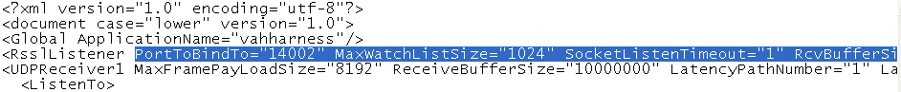
- In the configuration file ‘VahHarness->Config->VahHarnessConfig.xml’, set below parameter for ‘Message Relay’ Component correctly according to the setting of TG and local computer.
Configuration Item | Value
InterfaceToBindTo | VAHHAR-RELAY (Recommended)
PortToBindTo | 7775 (This is default value, to make sure it was conflicted with other port on the interface, please change it to be yours)
Multicastaddress | 239.232.252.1 (This is default value, please make sure it being same with TG setting (DestIPAddr) and not conflicted with other multicast addresses on the interface)
Multicastport | 7777 (This is default value, please make sure it being same with TG setting and not conflicted with other ports on the interface

Below is a screenshot example showing the location of the configuration item in the file.
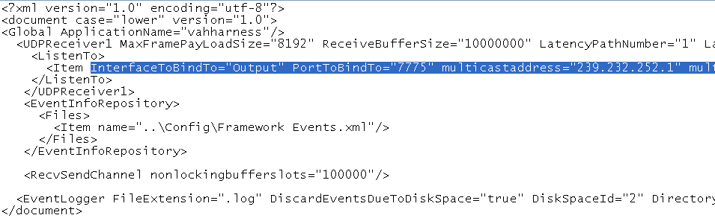
- In the configuration file ‘VahHarness->Config->VahHarnessConfig.xml’, below parameter is for ‘Item Stub’ Component.
Configuration Item | Value
TrwfConfig | Dictionary path for TRWF2.dat
StorageConfig | Dictionary path for market stream (L1) template
ItemConfig | Item configuration path
CBRConfig | CBR configuration path
PluginName | UI Plug-in DLL path
LoginConfig | Login response message path
DirectoryConfig | Directory response message path
RefreshTime | UI refresh time (second)

Below is a screenshot example showing the location of the configuration item in the file.
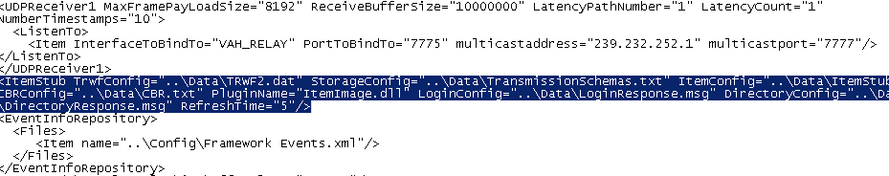

Setting ENV Parameter for VAH
- Please go to VAH working directory, in configuration file ‘VAH->Config->InputHandlerConfig.xml’, set below parameter correctly according to the setting of local computer.
Configuration Item | Value
ipaddress | IP address of VAHHAR-RSSL (Recommended)
portnumber | 14002 (this is default value and this port number should be same with VAH Harness ‘PortToBindTo’ configuration item)

Below is a screenshot example showing the location of the configuration item in the file.
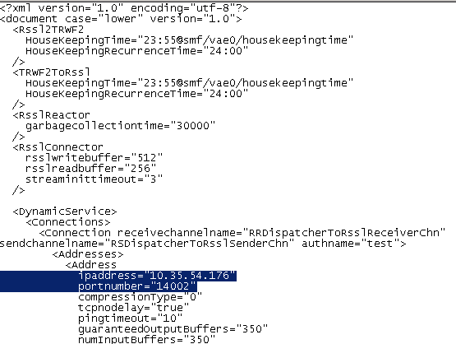

Setting ENV Parameter for TG
- In the configuration file ‘VahHarness-> Application-> Message-> TransportProfile.xml’, set below parameter correctly according to the setting of local computer.
Configuration Item | Value
DestIPAddr | 239.232.252.1 (This is default value, please make sure it being same with VAH Harness setting (Multicastaddress) and not conflicted with other multicast addresses on the interface)
DestPort | 7777 (This is default value, please make sure it being same with VAH Harness setting (Multicastport) and not conflicted with other ports on the interface
SourceIPAddr | IP address of VAHHAR-RELAY
SourcePort | 7778(This is default value, to make sure it was conflicted with other port on the interface, please change it to be yours)

Below is a screenshot example showing the location of the configuration item in the file.
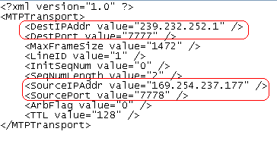

Launch VAH Harness

Launch VAH Harness
By executing bellow bat:
‘VahHarness->Script->StartupHarness.bat’
Following is a screenshot to indicate the launching is successful.
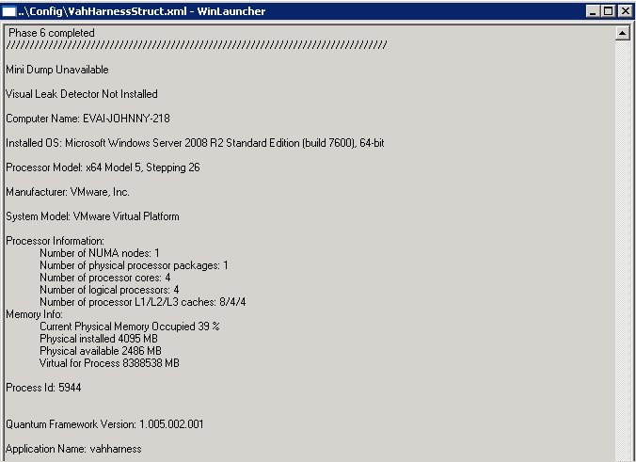

Launch VAH Harness UI
By executing bellow bat:
‘VahHarness->Script->StartupUI.exe’
The UI include 3 tabs:
Main Tab:
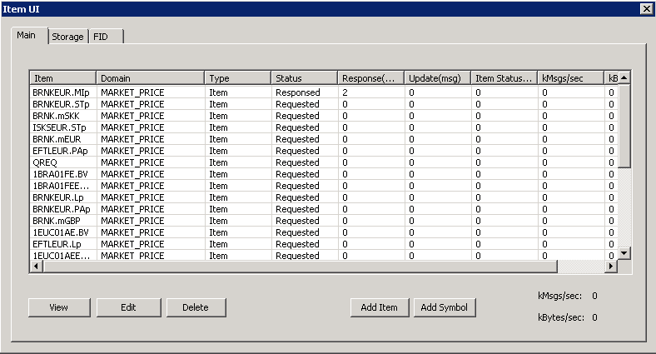
Item name

Domain Type

Item Type

Item Status

Message Num for Item

Message Rate for Item

Total Message Rate

Storage Tab:
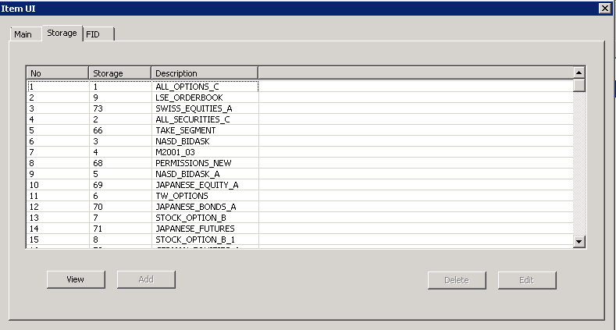
Storage ID

Description for Storage
FID Tab:
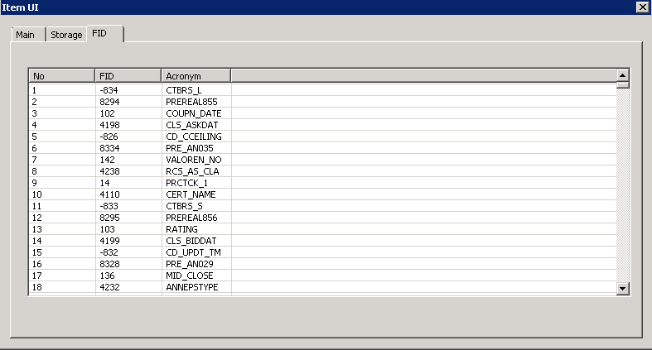
FID Number
FID Acronym

Launch VAH
The order of launching VAH and Harness is not important, but recommend to Launch Harness prior to the VAH in case VAH connection gets timeout.

Launch ‘Traffic Generator’
By executing bellow bat (Optional)
‘VahHarness->Script->StartupTG.bat’

Using VAH Harness
As a user of VAH Harness, you are assumed to be familiar with Traffic Generator and its XML Message Template.

Fabricate a Source Response Message
    - Fabricate a response message by TG
User can fabricate a Response Message by using ‘Traffic Generator’. (An example has been placed under ‘VahHarness->Message->SourceResponse.xml’). User should make sure a Response message was sent before any following Messages.
    - Fabricate a response message by VAH Harness
As you can see in the snapshot, the initial status of Item is “Requested” is VAH has requested this item. Select one item and click ‘Edit’ button, in the popup Dialog, you can configure constitute information by clicking ‘Edit’ button and then select Status and storage in the popup dialog. E.g. set this item with two constitutes, one is 73, and the other is 1.
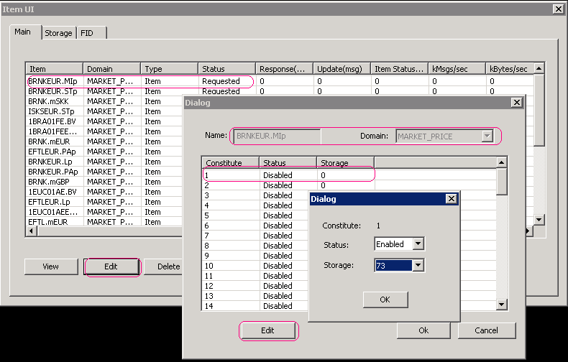
Then confirm the operation by clicking ‘OK’ button. You will find the constitute information has changed.
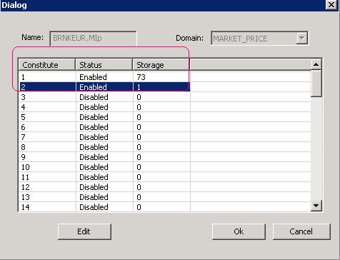
Again click ‘OK’ button and return to ‘Main’ pane. You will find the column of ‘Response (msg)’ of this item has changed to ‘3’, including 2 constitutes you just set plus the default constitute 0. And the Status has been changed from ‘Requested’ to ‘Responsed’
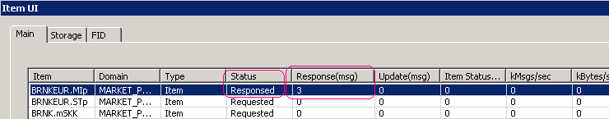

Send Following Update Message
After sending response message, we can relay update message to VAH now. An example has been placed under ‘VahHarness->Message->SourceUpdate.xml’. When VAH Harness relays update messages to VAH, the status will change from ‘Responsed’ to ‘Relaying’ as in below snapshot. Message rates (by number of message or bytes) are also displayed in VAH Harness, which should be the roughly same as that showed in TG.
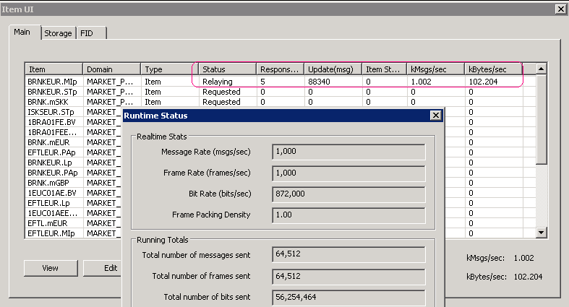

Appendix 1
How to install Microsoft loopback adapter on Windows Server 2008
Run “devmgmt.msc”
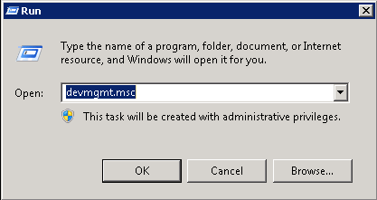
On the populated “Device Manager”, right click computer name and choose “Add legacy hardware”
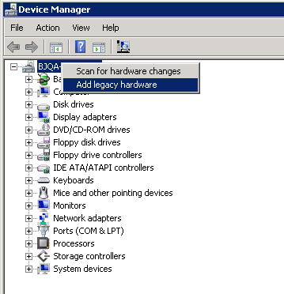
Click “Next” by default
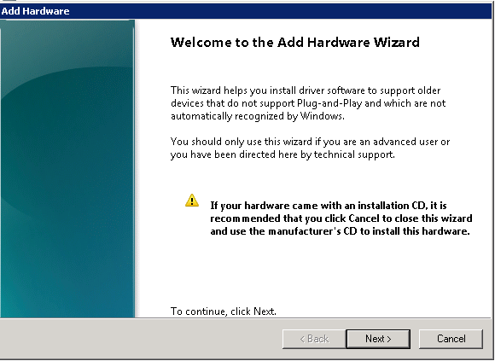
Choose “Install the hardware that I manually select from a list” and click “Next”
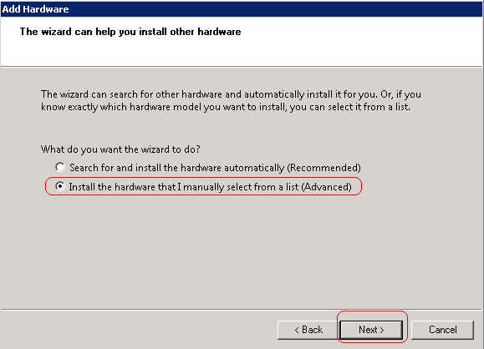
Select “Network adapters” and click “Next”
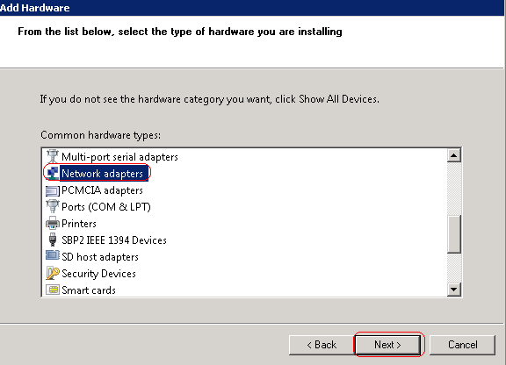
Choose “Microsoft” at left pane, and choose “Microsoft Loopback Adapter” on the right pane. Click “Next”.
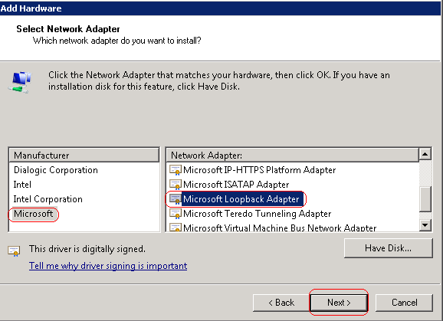
Click “Finish” by default
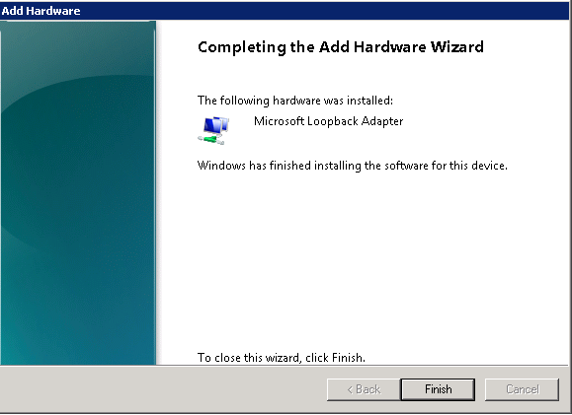
Enter into “Change adapter settings” as following path.
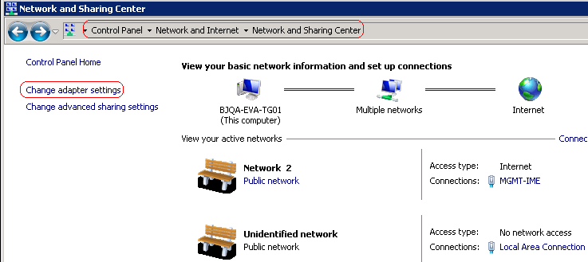
Edit the property of New Adapter
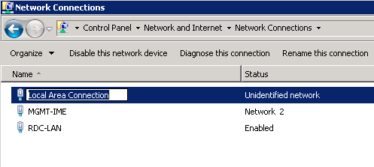
~~End of Document~~

